

Waltham on the wolds CE Primary school

SEND Information Report

Adopted by Neil Bardesley for Waltham CE primary school on:
Approved by Board of Directors: Sept 2025
Review Date: Sept 2026

SEND Information Report
CONTENTS

School context 3
What types of SEND does the school provide for? 3
Who are the best people to talk to at our school 3
about my child’s difficulties with learning / SEND?
What should I do if I think my child has SEND? 3
How will the school know if my child needs SEND support? 3
How will the school measure my child’s progress? 4

How will I be involved in decisions made about my child’s education? 4

How will my child be involved in decisions made about their education? 5

How will the school make sure my child is included in activities 5

alongside pupils who don’t have SEND?

What support will be available for my child as they transition between 6 classes or settings?

What should I do if I have a complaint about my child’s SEND support? 6

School context
At Waltham CE primary school we are a fully inclusive school; we recognise every pupil’s right to a broad and balanced curriculum and we celebrate diversity. Teachers and support staff are highly skilled at supporting children with SEND in class and identifying those that require further support.
In Autumn 2025 our SEND profile shows that we have 12,9%, 16 children identified as having SEND. This percentage is made up of the following groups:
18.7% are identified as having SEND linked to Cognition and Learning (including maths, reading, writing and spelling etc.)
31.2% are identified as having SEND linked to Communication and Interaction (including speech and language difficulties and problems with social interaction)
12.5 % are identified as having SEND linked to Physical and sensory (including disabilities such as those affecting mobility, sight and hearing)
37.5 % are identified as having SEND linked to Social, Emotional and Mental Health Difficulties (including ADHD, ADD, Attachment Disorder, Anxiety and Depression)

What types of SEND does the school provide for?
Pupils with SEND are considered for admission to Waltham on exactly the same basis as pupils without SEND. The Academy will not discriminate against disabled pupils or prospective pupils on the grounds of disability and will strive to provide an accurate provision for pupils with SEND. In the case of pupils with an EHCP naming the Academy, they will be admitted, unless after reviewing the EHCP the Academy believes that it cannot meet need and that to admit the child would be an incompatible and inefficient use of both Academy and LA funds.

Who are the best people to talk to at our school about my child’s difficulties with learning / SEND?
Every class teacher has responsibility for:
• checking on the progress of your child
• identifying, planning and delivering the differentiated curriculum for your child in class as required • personalised teaching and learning for your child
• ensuring that the school’s SEND Policy is followed in their classroom.
At Waltham, Mrs Sam Pearson( Senior teacher / SENDCO) holds responsibility for the leadership and day to day management of SEND provision. If you have any queries or concerns, that can’t be answered by the class teacher, you should book an appointment through the school office.

What should I do if I think my child has SEND?
If you have concerns about your child’s progress or think they might have a special educational need you should, in the first instance, speak to your child’s class teacher. If necessary, they will arrange a time that they can meet with you to fully discuss your concerns. The class teacher will discuss your child’s learning needs and interventions that are in place to meet your child’s needs. They will then discuss your concerns with the SENCO, Mrs Sam Pearson who will decide how SEND support can be identified. Parents of children identified as needing SEND support will be invited to a meeting to discuss the provision made for their child. If you have concerns that your child has an unmet special educational need after speaking to one of the above staff, you should contact Sam Pearson / Nikki Copeland through the school office.
If you have questions about SEND, or are struggling to cope, please get in touch to let us know. We want to support you, your child and your family.
To see what support is available to you locally, have a look at your local authority’s local offer. Leicestershire county publishes information about the local offer on their website: Leicestershire's SEND Local Offer | Leicestershire County Council

How will the school know if my child needs SEND support?
Pupils can be identified as having SEND at any point during their time at the Academy, including:
- Upon admission to the Academy, from information from parents/carers or external agencies
- During transition to the Academy, from information shared by the previous school
- From class assessments
- When staff raise concerns that a pupil is underachieving or struggling
- Through data analysis, including reading assessments, screeners and termly common assessments
- If external agencies are involved with a student

You will then be contacted by Sam Pearson ( Senior teacher / SENDCO) to discuss our concerns. At this point you will be consulted regarding an action plan of support and the planned provision for your child.

How will the school measure my child’s progress?
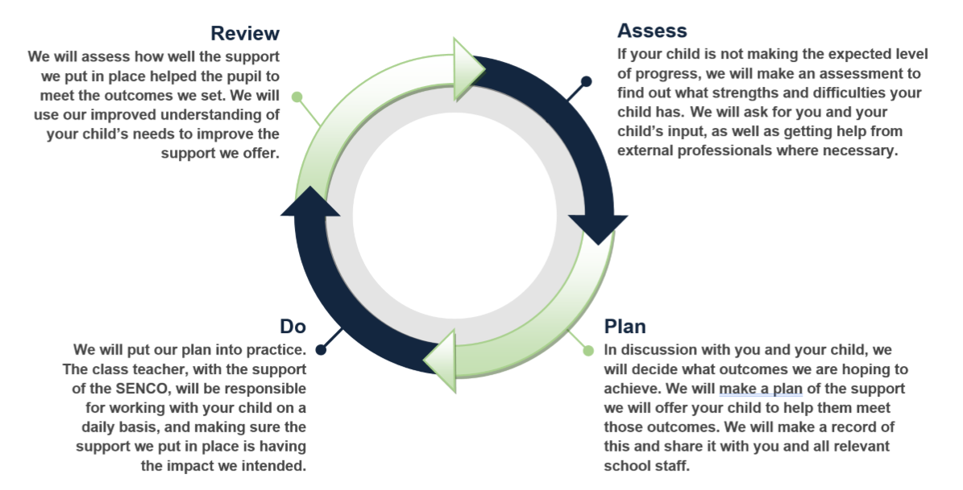
The graduated approach is a 4-part cycle of assess, plan, do, review.

As a part of the planning stage of the graduated approach, we will set outcomes that we want to see your child achieve.
Whenever we run an intervention with your child, we will assess them before the intervention begins. This is known as a ‘baseline assessment’. We do this so we can see how much impact the intervention has on your child’s progress.
We will track your child’s progress towards the outcomes we set over time and improve our offer as we learn what your child responds to best.

How will I be involved in decisions made about my child’s education?

We will provide an annual report on your child's progress. Your child’s class teacher will meet you at a minimum 3 times a year, to:
- Set clear outcomes for your child’s progress
- Review progress towards those outcomes
- Discuss the support we will put in place to help your child make that progress
- Identify what we will do, what we will ask you to do, and what we will ask your child to do

The SENDCO may also attend these meetings to provide extra support.
We know that you’re the expert when it comes to your child’s needs and aspirations. So we want to make sure you have a full understanding of how we’re trying to meet your child’s needs, so that you can provide insight into what you think would work best for your child.
We also want to hear from you as much as possible so that we can build a better picture of how the SEND support we are providing is impacting your child outside of school.
If your child’s needs or aspirations change at any time, please let us know right away so we can keep our provision as relevant as possible.
After any discussion we will make a record of any outcomes, actions and support that have been agreed. This record will be shared with all relevant staff, and you will be given a copy.
If you have concerns that arise between these meetings, please contact your child’s class teacher through the school office at: "office@waltham.risemat.co.uk" office@waltham.risemat.co.uk

How will my child be involved in decisions made about their education?

The level of involvement will depend on your child’s age, and level of competence. We recognise that no 2 children are the same, so we will decide on a case-by-case basis, with your input.
We may seek your child’s views by asking them to:
- Attend meetings to discuss their progress and outcomes
- Prepare a presentation, written statement, pictures, video, drawing, etc.
- Discuss their views with a member of staff who can act as a representative during the meeting
- Complete a survey

How will the school adapt its teaching for my child?
Our teachers use adaptive teaching strategies in all curriculum areas to ensure learning is accessible to all pupils. This includes planning adaptations to activities before the lesson, making adjustments whilst teaching and through small group learning.
Adaptations to the curriculum or learning environment may be made to remove barriers to learning but these are very dependent on every childs’ individual needs.

How will the school make sure my child is included in activities alongside pupils who don’t have SEND?
All of our extra-curricular activities and school visits are available to all our pupils, including our before and after-school clubs.
All pupils are encouraged to go on our school trips, including our year 6 residential trip to PGL Caythorpe.
All pupils are encouraged to take part in sports day/school plays/special workshops.
No pupil is ever excluded from taking part in these activities because of their SEND or disability and we will make whatever reasonable adjustments are needed to make sure that they can be included. It may be appropriate to risk-assess the activity to ensure safety elements have been considered.

What support will be available for my child as they transition between classes or settings?
We understand that transitions can be particularly difficult for pupils with special educational needs and we work closely with other schools and agencies to ensure as smooth a process as possible.

Between classes
To help pupils with SEND be prepared for a new school year we:
Ask both the current teacher and the next year’s teacher to meet to discuss the pupil’s SEND needs.
Schedule lessons with the incoming teacher towards the end of the summer term.
Offer parent meetings to discuss their child’s needs with the incoming teacher.

Between settings
The SENDCO of the secondary school will meet with our SENDCO and Year 6 teacher. They will discuss the needs of all the children who are receiving SEN support.

Pupils will be prepared for the transition by:
Practising with a secondary school timetable
Learning how to get organised independently
Plugging any gaps in knowledge
Organise extra visits to their new secondary school

What should I do if I have a complaint about my child’s SEND support?
If you have a concern about the provision for your child there are procedures outlined in the School’s Complaints Policy.
If there continues to be disagreement with regard to SEND provision following meetings with the school, SENDIASS is an organisation that provides free, impartial and confidential advice and support to parents and carers of young people aged 0-25 with special education needs, their contact information is below.

https://sendiassleicestershire.org.uk
https://sendiassleicester.org.uk/

